|  |
| --- |
| **OBJECTIVES** |
| Phone lesson |
|  |
|  |

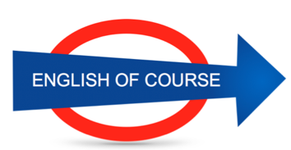

**Date**

**19/10/2016**

**Hours**

**2/**

**Session**

**2**

|  |  |
| --- | --- |
| **NEW VOCABULARY** | |
| Some job to finish | Some work to finish |
| We have done the tournament | To participate |
| Ligaments |  |
| Knee | Silent “k” |
| Meniscus |  |
| I arrive | I manage |
| Apnoea | Apnee |
| orienteering |  |
| A hot topic |  |
| There could be | Il peut y avoir |
|  |  |
|  |  |
|  |  |
|  |  |
|  |  |
|  |  |
|  |  |
|  |  |
|  |  |
|  |  |
|  |  |
|  |  |
|  |  |
|  |  |
|  |  |
|  |  |
|  |  |
|  |  |
|  |  |
|  |  |
|  |  |
|  |  |
|  |  |
|  |  |
|  |  |
|  |  |
|  |  |
|  |  |

**GRAMMAR**

**We are doing some exercises 🡪 we do exercises**

**Future Objectives**

**Lesson Summary**

**Next Lesson**

DATE

21/09

TIME 14.00