|  |
| --- |
| **OBJECTIVES** |
| Oral comprehension |
| Bbc news one minute |
| C CNN student news |

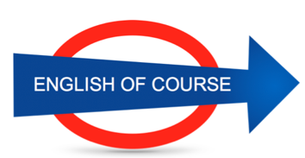

**Date**

**12/10/2016**

**Hours**

**1,5/**

**Session**

**1**

|  |  |
| --- | --- |
| **NEW VOCABULARY** | |
| The corridor |  |
| Goggles | Safety glasses |
| Safety audit |  |
| Turnover was stagnating |  |
| To comply with |  |
| The fence | A gate |
| To back a project | To support |
| To back someone | To support |
| I stick with my ideas | I’m not changing my mind |
| Competition is fierce | Strong |
| A long way to go |  |
| A drop in a bucket |  |
| To get back on your feet |  |
|  |  |
|  |  |
|  |  |
|  |  |
|  |  |
|  |  |
|  |  |
|  |  |
|  |  |
|  |  |
|  |  |
|  |  |
|  |  |
|  |  |
|  |  |
|  |  |
|  |  |
|  |  |
|  |  |
|  |  |
|  |  |
|  |  |
|  |  |
|  |  |
|  |  |

**GRAMMAR**

***~~Until~~* we’ve had strict safety measures since the beginning of the year / for 10 months**

**I’ve been working here since 2011 / for 5 years**

**There has been a progression in the last 10 years**

**~~I am watching~~ I don’t watch a lot of TV**

**We couldn’t manage to work correctly**

**Future Objectives**

**Lesson Summary**

**Next Lesson**

DATE

21/09

TIME 14.00