|  |
| --- |
| **OBJECTIVES** |
| Minimum wage video (american accent) |
|  |
|  |
|  |

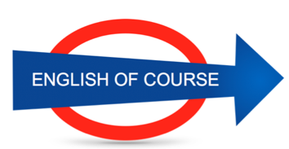

**Date**

**04/11/2016**

**Hours**

**3/**

**Session**

**2**

|  |  |
| --- | --- |
| **NEW VOCABULARY** | |
| Mulled wine | Vin chaud |
| Gradually becoming confident |  |
| To have tied hands | Les mains liées |
| A polish guy |  |
| To look up a word | Chercher |
| I was reassured |  |
| Experiences |  |
| Effort |  |
| Each lunch time |  |
| Interest**ing** |  |
| To update the database |  |
| In a clever way | D’une façon intelligente |
| Without thinking |  |
| To get bored | S’ennuyer |
| To sue | Porter plainte |
| To file a complaint |  |
| To take to court | Emmener au tribunal |
| The consumption changes |  |
| To weld | Souder |
| To gain market shares | Gagner des parts de marché |
| To succeed |  |
| To score points |  |
| Output | rendement |
| Breakdowns | Pannes |
| Gearing / leverage | Effet de levier |
| To apply | Appliquer |
| A shortage | Une penurie |
| To promote |  |
| I was promoted to |  |
| Alloy wheels | Jantes alu |
| Visual aspect |  |
| A survey / a poll | Un sondage |
| I’m afraid of |  |
| To lie | Mentir |
|  |  |
|  |  |
|  |  |
|  |  |

**GRAMMAR**

ans**w**er (silent letter w)

purchasing terms and conditions

new technologies are available on the market

the country is on board (to agree with)

**Future Objectives**

Gerund or infinitive

**Lesson Summary**

**Next Lesson**