|  |
| --- |
| **OBJECTIVES** |
| Unit 5 Can / could |
| Was / were |
| Word combinations |

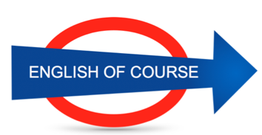

**Date**

**09/11/2016**

**Hours**

**9/**

**Session**

**7**

|  |  |
| --- | --- |
| **NEW VOCABULARY** | |
| To taste | Gouter |
| Chocolate festival |  |
| Building permits |  |
| Busy |  |
| Relaxing holidays |  |
| Meals | Repas |
| Easter holiday | Paques |
| To owe | Devoir |
| Debt of gratitude |  |
| To see through | Au travers |
| I can ski a bit | A little |
| Enough | Suffisamment |
| Quite well | Assez bien |
| Really well | Vraiment bien |
| Cello | Violoncelle |
| Highway (US)autoroute | Motorway (GB) |
| Car park |  |
| Railway station | Gare |
| Traffic lights | Feux tricolores |
| To look after | S’occuper de |
| Mind your own business | Occupe toi de tes affaires |
| Own | Propre |
| Owner | proprio |
| A ride | Un tour |
|  |  |
|  |  |
|  |  |
|  |  |
|  |  |
|  |  |
|  |  |
|  |  |
|  |  |
|  |  |
|  |  |
|  |  |
|  |  |
|  |  |

**GRAMMAR**

**CAN / CAN’T + base form**

**I can play // I can ~~to~~ play**

**Before I used to play the piano**

**Future Objectives**

**Lesson Summary**

**Next Lesson**

DATE

21/09

TIME 14.00