|  |
| --- |
| **OBJECTIVES** |
| BBC news podcast |
|  |
|  |

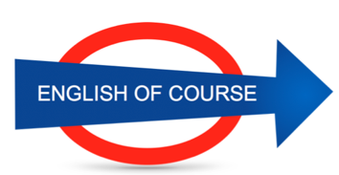

**Date**

**04/11/2016**

**Hours**

**8/**

**Session**

**8**

|  |  |
| --- | --- |
| **NEW VOCABULARY** | |
| Sole | Semelle |
| Up to the knees | Jusqu’aux genoux |
| Time flies | Le temps passe |
| To intensity efforts |  |
|  |  |
|  |  |
|  |  |
|  |  |
|  |  |
|  |  |
|  |  |
|  |  |
|  |  |
|  |  |
|  |  |
|  |  |
|  |  |
|  |  |
|  |  |
|  |  |
|  |  |
|  |  |
|  |  |
|  |  |
|  |  |
|  |  |
|  |  |
|  |  |
|  |  |
|  |  |
|  |  |
|  |  |
|  |  |
|  |  |
|  |  |
|  |  |
|  |  |
|  |  |

**Future Objectives**

**GRAMMAR**

**Lesson Summary**

**Next Lesson**

DATE

09/09

TIME 12.00