|  |
| --- |
| **OBJECTIVES** |
|  |
|  |
|  |

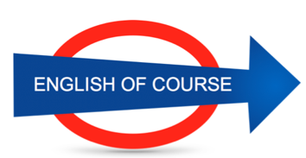

**Date**

**04/10/2016**

**Hours**

**4,5/**

**Session**

**3**

|  |  |
| --- | --- |
| **NEW VOCABULARY** | |
| DIY (do it yourself) | Bricolage |
| Resin |  |
| It will be completed |  |
| I got 520 |  |
| Half a dozen | Une demi douzaine |
| Too busy | Trop occupé |
| To forget / forgot | Oublier |
| It must have slipped my mind | J’ai completement oublié |
| Food |  |
| Fruit (froute) |  |
| The stairs | Escaliers |
| The staircase | La cage d escaliers |
| Nevertheless | Neanmoins |
| Therefore | Donc |
| However | Cependant (but) |
| Although | Bien que |
|  |  |
|  |  |
|  |  |
|  |  |
|  |  |
|  |  |
|  |  |
|  |  |
|  |  |
|  |  |
|  |  |
|  |  |
|  |  |
|  |  |
|  |  |
|  |  |
|  |  |
|  |  |
|  |  |
|  |  |
|  |  |
|  |  |

**GRAMMAR**

**I went for a few drinks with friends**

**It didn’t rain**

If + present , …. Will

If it rains this weekend, I will go to the cinema

If + past, … would / could (unreal)

If I won the lottery, I would buy a sportscar

If + pluperfect , …. Would have + past participle

If I had known, I would have paid less. (si j avais su, j aurais payé moins)

To want something done (to want something + past participle)

I want this email sent by tomorrow

**Future Objectives**

**Lesson Summary**

**Next Lesson**

DATE

21/09

TIME 14.00