|  |
| --- |
| **OBJECTIVES** |
| Taboo game (animals / fear / honey) |
|  |
|  |
|  |
|  |

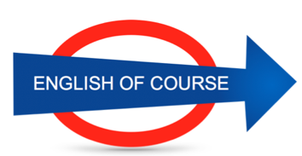

**Date**

**13/10/2016**

**Hours**

**15/**

**Session**

**8**

|  |  |
| --- | --- |
| **NEW VOCABULARY** | |
| Meaning | Signification |
| Mouth (maouf) |  |
| Mouse (maousse) |  |
| Martial arts |  |
| Stone | Pierre |
| Fear | Peur |
| Napkin | Serviette |
| Towel | Serviette (bath) |
| Shut it off | Switch it off |
| Software | Logiciel |
| Hardware | Peripherique |
| To give up | To stop |
| To be on the rise | To increase |
| A refund | To get your money back |
| Funds | fonds |
| To refund someone |  |
| To be refunded |  |
| Device | Appareil |
| To stick by my ideas | Not to change my mind |
| Brand | Marque |
| Fierce competition | strong |
| Competitor | Concurrent |
| Registration card |  |
|  |  |
|  |  |
|  |  |
|  |  |
|  |  |
|  |  |
|  |  |
|  |  |
|  |  |
|  |  |
|  |  |
|  |  |
|  |  |
|  |  |

**GRAMMAR**

Phones have to turn off // people have to turn off their phones (active)

Phones have to be turned off (passive) and not charged / given back to the store

I left the company 6 years ago

**Next Lesson**

Tuesday 30th

9.00

**Lesson Summary**

**Future Objectives**