|  |
| --- |
| **OBJECTIVES** |
| How to talk about money |
| 2nd conditional |
| Employee relations RH |
|  |
|  |

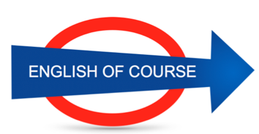

**Date**

**06/08/2016**

**Hours**

**7,5/**

**Session**

**5**

|  |  |
| --- | --- |
| **NEW VOCABULARY** | |
| To look after |  |
| Apparently |  |
|  |
| Worldwide | Everywhere |
| Vulgar |  |
| To express regrets over |  |
| Song |  |
| Jam | Confiture |
| Fruit purée | Compote |
| A café |  |
| A deposit | Un apport |
| To give |  |
| To borrow | Emprunter |
| To pay back | To give back money |
| To reimburse |  |
| A direct debit | Un prelevement |
| Square metres | M2 |
| Colour / color |  |
| Just under … |  |
| A lame excuse | Une excuse bidon |
| To work Overtime | Extra hours |
| To clear dates |  |
|  |  |
|  |  |
|  |  |
|  |  |
|  |  |
|  |  |
|  |  |
|  |  |
|  |  |
|  |  |
|  |  |
|  |  |
|  |  |
|  |  |
|  |  |

**GRAMMAR**

What time do people have dinner?

Who is the famous actor (~~which~~)?

first conditional = probability is high

If I have €10,000, I will buy a new bike

If it rains tomorrow, I will go to the cinema

2nd conditional = low probability

if I had €10,000, I would

**Next Lesson**

Tuesday 30th

9.00

**Lesson Summary**

**Future Objectives**