|  |
| --- |
| **OBJECTIVES** |
| Whatever makes you happy Unit 2 (finished) |
|  |
|  |
|  |
|  |

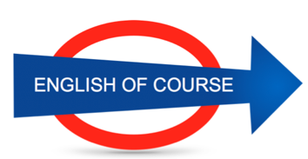

**Date**

**04/11/2016**

**Hours**

**19,5/**

**Session**

**10**

|  |  |
| --- | --- |
| **NEW VOCABULARY** | |
| Treat or trick? |  |
| I have the impression |  |
| I have the feeling |  |
| Summons | Une convocation |
| Cease fire | Cessez le feu |
| To have the final say | Le dernier mot |
| Fingerprint | Empreintes |
| Shape | Forme |
| Parts | Pieces |
| Hole | Trou |
| Wheel | Roue |
| To put out fire | Extinguish |
| Thief (fif) | Voleur |
| I got cut off | Disconnected |
| A plan of attack |  |
| My bad | Ma faute / désolé |
| I’m breaking up | Ça coupe |
| I’m in the dead spot | Je passe sous un tunnel |
| To get on with s.o | S’entendre |
| To dye your hair | Se teindre |
| Deaf | You can’t hear |
| Death |  |
| Corkscrew | Tire bouchon |
| Can opener | Decapsuleur |
| Broom | balai |
|  |  |
|  |  |
|  |  |
|  |  |
|  |  |
|  |  |
|  |  |
|  |  |
|  |  |
|  |  |
|  |  |
|  |  |

**GRAMMAR**

Children have a toy ~~who~~ which

Any questions before we move on to the next topic / item on the agenda .

Given sales results = etant donné les resultats des ventes

It’s the taste you’re familiar with.

**Next Lesson**

Tuesday 30th

9.00

**Lesson Summary**

**Future Objectives**

Words: Taboo 1